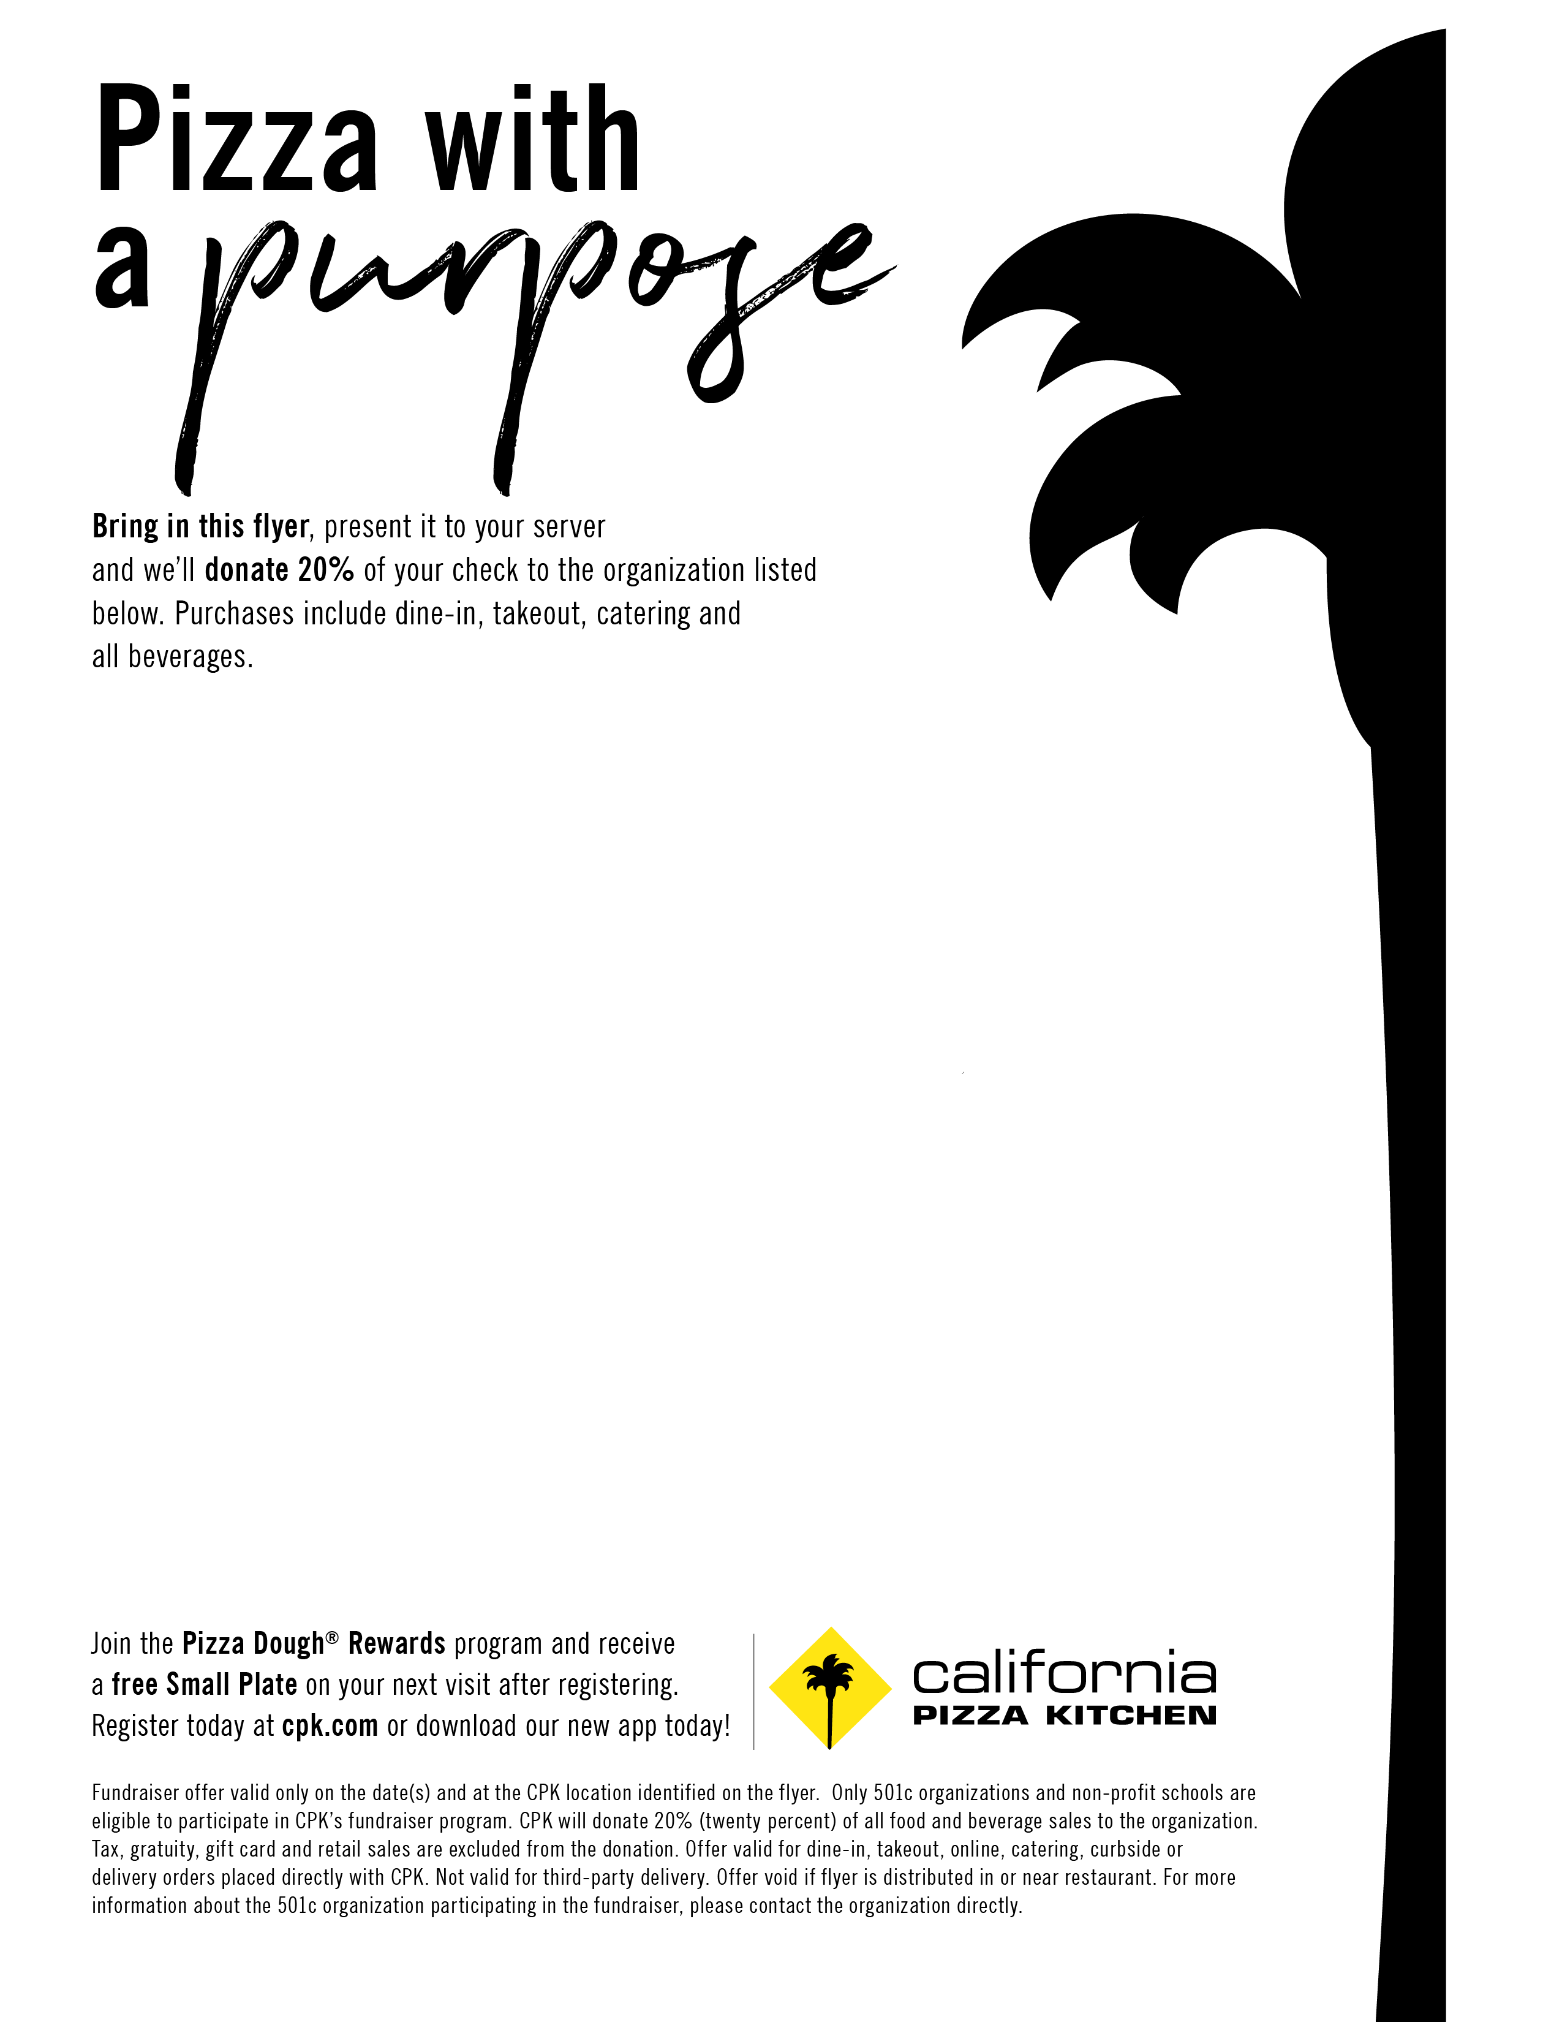

**Fundraiser Spirit Night in support of:**



**Hermitage High Athletic Boosters**

**Thursday February 28th, 2019**

**Office/Work delivery**, lunch, and dinner included in total funds raised, so parents can support ALL DAY!

Call for office delivery!

**Bring as many people as you can—dine in or**

**takeout! Share!**

804-364-9047

**Valid at the following location:  
California Pizza Kitchen**Short Pump Town Center

11800 W. Broad Street

804-364-9047